**BOOK A DOCTOR**

**REPORT**

**Group 438-**

**ISHAN PAL – 20BCE10285**

**ABHAY SINGH RANA – 20BCE10314**

**DEEPAK KUMAR – 20BCE10660**

**SHREYANSH PANDEY – 20BCE10404**

# INTRODUCTION:

## OVERVIEW:

The proposed project is an intelligent system for booking appointments with doctors, allowing patients and users to easily schedule appointments online. It is a web-based application that addresses the challenges of managing and scheduling appointments based on user preferences and demands. Manual allocation of appointments by the pharmacist or doctor can be a tedious task, considering the availability of the users. Therefore, this project offers an effective solution where users can view available time slots and select their preferred date and time. Already booked slots are marked in yellow and cannot be selected by others during that specified time. Additionally, users have the flexibility to cancel their bookings at any time.

The application has been designed to minimize errors during data entry and provides error messages for invalid inputs. Users do not require formal knowledge to use the system, making it user-friendly.

The Doctor Appointment System described above ensures an error-free, secure, reliable, and efficient management system. It allows users to focus on their other activities instead of record-keeping, ultimately leading to better resource utilization for the organization

1. **User Registration and Profiles:** The web app provides a registration process where users can create their accounts. Users can then log in to access personalized features, such as order history, saved addresses, and preferences.
2. **Menu Display:** The web app displays menus from various doctor appointments. Users can browse through categories, view details, and see dates and available timing.
3. **Appointment:** Users can search for specific appointments and filter them based on criteria. This helps users quickly find their schedule dates from a wide selection.
4. **Administration Dashboard:** The web app also includes an administration dashboard accessible to users or administrators. This dashboard allows them to

manage, update item availability, view and slots, generate reports, and perform other administrative tasks.

## PURPOSE:

The purpose of a book a doctor appointment system is to improve the process of scheduling appointments with healthcare professionals. It aims to provide several benefits to both patients and healthcare providers:

1. Convenience for Patients: The system allows patients to easily find and book appointments with doctors at their preferred date, time, and location. It eliminates the need to make phone calls or visit the healthcare facility in person, saving time and effort.

2. Time Efficiency: By providing real-time availability information, the system enables patients to quickly find open appointment slots without the need for back-and-forth communication with the healthcare provider's office. This streamlines the process and reduces waiting times.

3. Improved Access to Healthcare: The system ensures that patients have access to a comprehensive database of doctors, including their specialties and qualifications. It helps patients find the right doctor who can address their specific healthcare needs, thus improving the quality of care they receive.

4. Reduced Administrative Burden: For healthcare providers, the system automates the appointment scheduling process, reducing the administrative workload associated with managing appointments manually. This allows staff to focus on other important tasks, such as patient care.

Overall, the purpose of a book a doctor appointment system is to enhance the accessibility, efficiency, and convenience of healthcare services. It benefits both patients and healthcare providers by simplifying the appointment scheduling process, reducing administrative burdens, and improving the overall patient experience.

# LITERATURE SURVEY:

## Existing Approach/Methods for this problem :

The literature survey of the project suggests an idea that is an intelligent system that makes it simple for patients and users to make online appointments with doctors. The difficulty of maintaining and scheduling appointments based on consumer requests and preferences is addressed by this web-based tool. Every single day we find numerous patients coming to the hospitals for either regular check-ups or for some serios ailments that need the supervision of the doctor. People run to the chemists or compounders to book themselves an appointment and it gets really hectic for them to reach to the doctor and book their appointments and reach for the appointment on time. They either have to wait in long queues for their turn to come, or sometimes are not even able to get the appointment on the required date and time. Also, considering the users' availability, the chemist or doctor may find it onerous to manually assign appointments.

Since consumers may browse available time slots and choose their favorite date and hour, this project provides a useful solution. This way it demolishes our second issue, of patients being sick and still needing to wait in long queues for their turns to arrive. In the project, yellow-marked slots are unavailable to other users during that time period since they have already been reserved. Additionally, individuals have the freedom to cancel their reservations whenever they choose. This makes it extremely easy and less time-consuming for everyone to get themselves checked-up by the doctor.

The application has been created to reduce the manual mistakes made when entering data and to display error messages for invalid inputs. This prevents the patients from committing the frauds against the doctors and pay them less, or not pay them at all, taking advantage of the doctors' negligence. Moreover, the system is user-friendly because it doesn't require formal training for users to operate it.

The management system is error-free, secure, dependable, and effective, by virtue of the doctor appointment system mentioned above. Therefore, the users are now able to concentrate on other tasks rather than record-keeping. The compounders in the hospitals too, need not maintain records, as the records are directly stores in the database of the application, which eventually results in improved resource allocation for the organization.

## PROPOSED SOLUTION:

Our team strongly recommends the implementation of a web-based book a doctor appointment system as it harnesses the power of technology to provide convenient services that enhance the lives of users. By leveraging technology, we can offer a seamless booking experience, enabling individuals to save valuable time, effort, and mental energy.

The proposed solution for a book a doctor appointment system typically involves the development of an online platform or mobile application that integrates various features and functionalities to facilitate the appointment scheduling process. Here is a high-level overview of the proposed solution. The proposed solution aims to provide a general framework for building such a system to improve the appointment scheduling process and enhance the overall healthcare experience.

# THEORITICAL ANALYSIS:

* 1. **BLOCK DIAGRAM:**

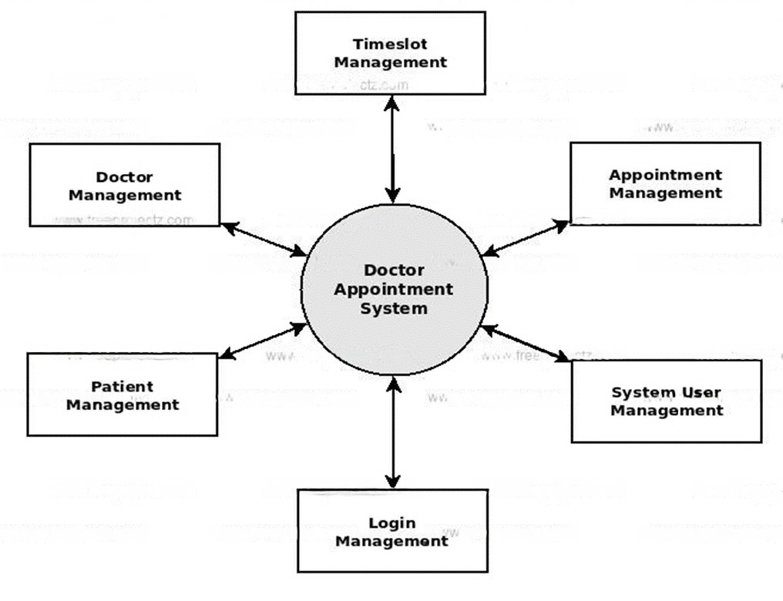

## 3.2) REQUIREMENTS OF PROJECT:

**Hardware Requirements:** Laptop/ Monitor with internet

**Software Requirements:** Operating system, Java Development Kit (JDK), Spring Boot, Integrated Development Environment (IDE)(Eclips/intellij), MySQL Database, Web Server(TOMCAT),Security(https)**.**

# EXPERIMENTAL INVESTIGATION:

While working on a web-based book a doctor appointment system, there are several aspects we analyzed and investigated to ensure its effectiveness and success. Here are some key areas where we have considered :

* **User Experience**: Analyze the user journey and interface of the web application to ensure it is intuitive, user-friendly, and optimized for different devices and screen sizes. Investigate user feedback, conduct usability tests, and iterate on the design to enhance the overall user experience.
* **Performance and Scalability:** Evaluate the performance of the web application, including page load times, response times, and handling concurrent user requests. Investigate potential bottlenecks and optimize the system's scalability to accommodate increasing user demand.

* **Security and Data Protection**: Analyze the security measures implemented within the web application to protect user data, including secure authentication, encryption of sensitive information, and adherence to data protection regulations. Conduct security audits and penetration testing to identify and address any vulnerabilities.
* **Appointment Management and Tracking:** Investigate the efficiency and accuracy of order management processes, including order placement, inventory management, and real-time order tracking. Analyze the system's ability to handle order modifications, cancellations, and refunds effectively.
* **Customer Support and Feedback:** Analyze the customer support mechanisms in place, such as chatbots, FAQs, and feedback channels. Investigate customer satisfaction levels and response times to ensure efficient and satisfactory support.
* **Mobile Responsiveness:** Investigate the mobile responsiveness of the web application to ensure a seamless experience across different mobile devices

Analyze user behavior and preferences on mobile devices and make necessary optimizations.

By conducting thorough analysis and investigation in these areas, we have identified areas for improvement, optimize the performance and user experience of the web- based food ordering system, and ultimately provide a seamless and satisfactory ordering experience for customers.

# FLOW CHART:

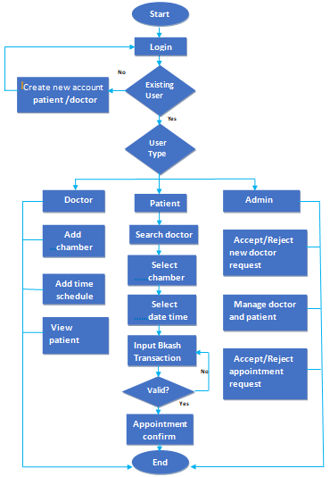

.

# RESULT (OUTPUT Screen shots):

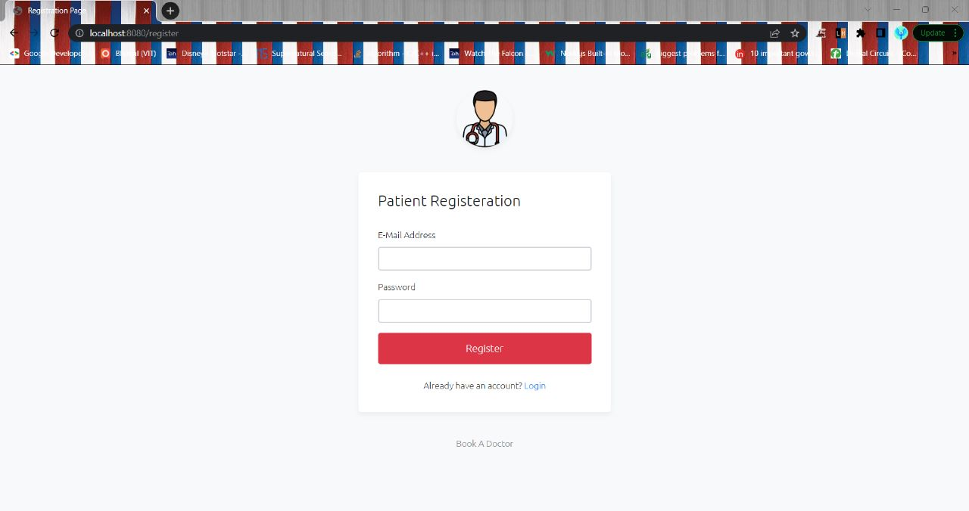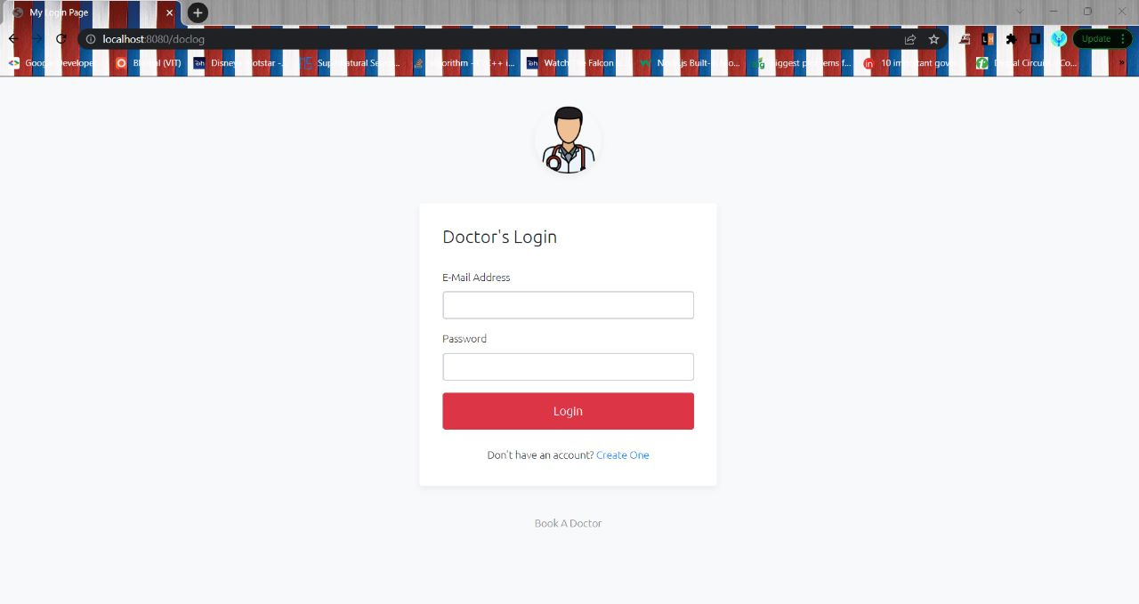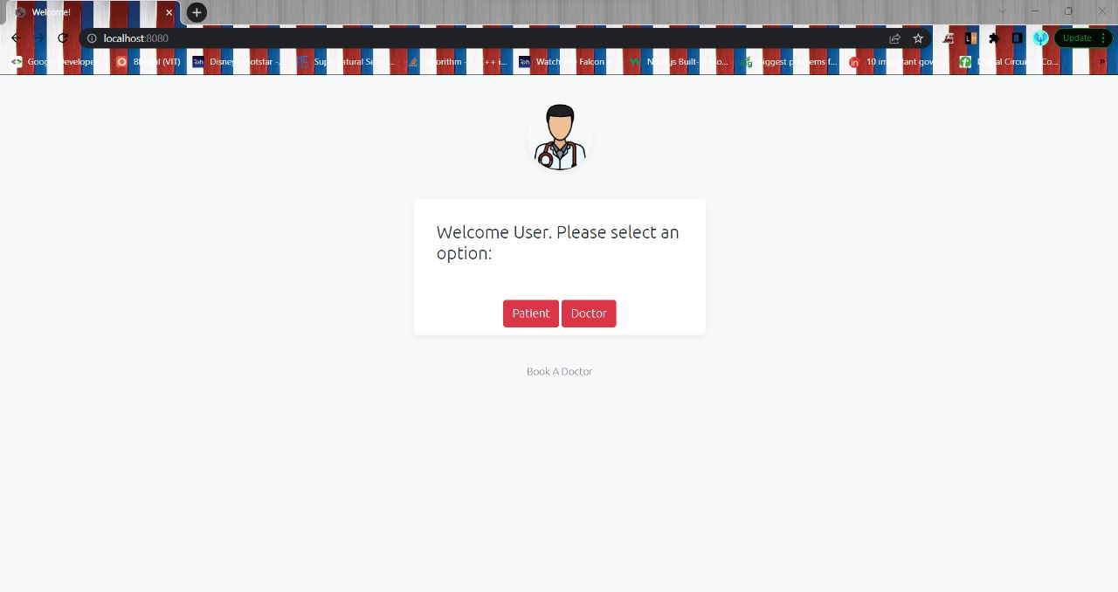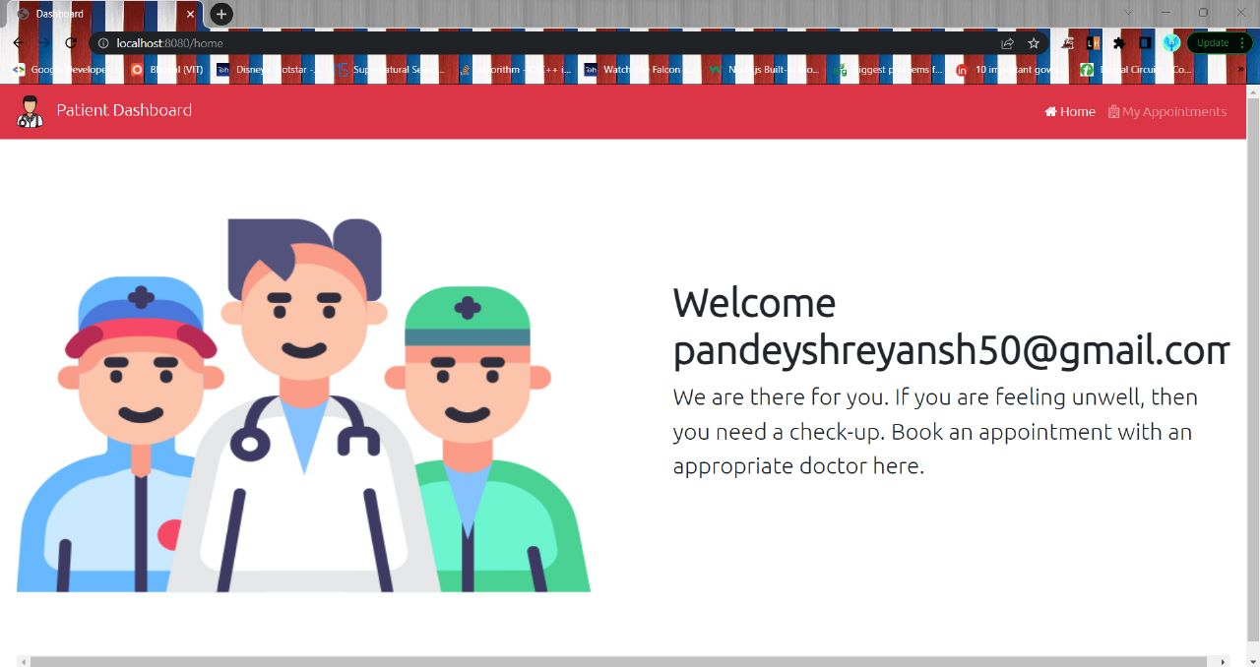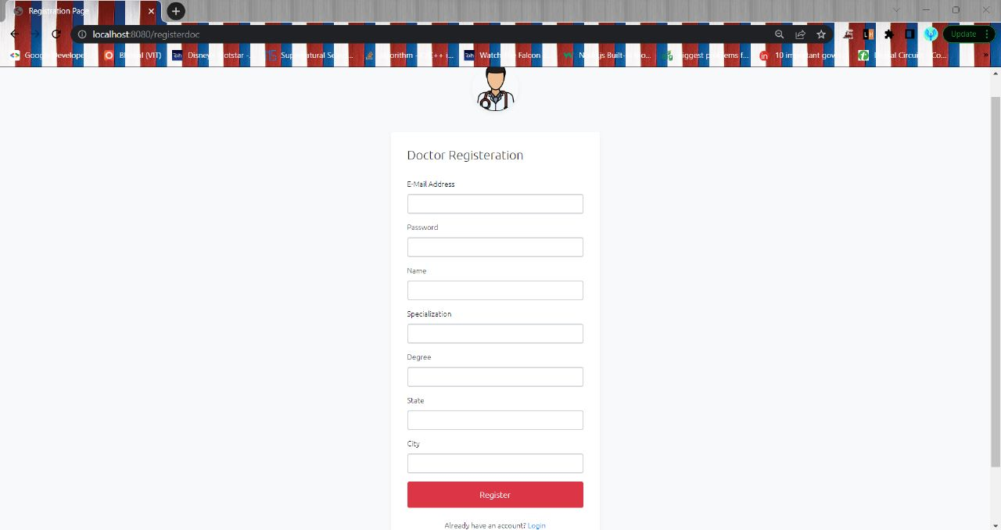

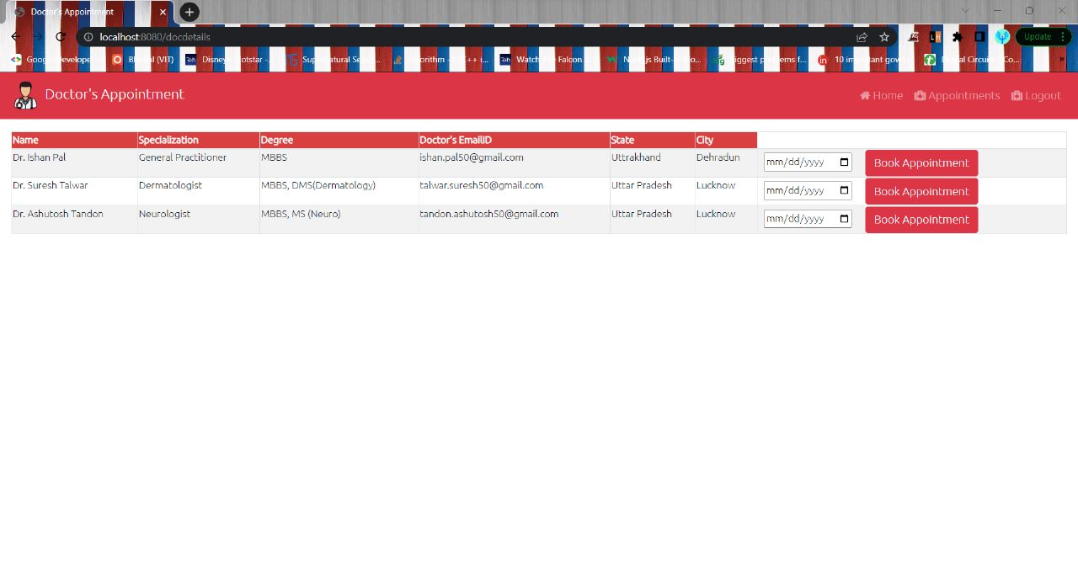

## ADVANTAGES & DISADVANTAGES:

* **Convenience:** Booking an appointment allows you to choose a suitable date and time that works for you, based on the doctor's availability. This helps you avoid long waiting times at the doctor's office.
* **Time Management:** By booking an appointment, you can plan your day accordingly, reducing the time spent waiting at the clinic. It allows you to schedule other activities without worrying about the uncertainty of when you'll be seen by the doctor
* **Priority Access:** Appointments often prioritize individuals who have booked in advance, ensuring that their medical concerns are addressed promptly. This can be beneficial for patients with urgent or time-sensitive conditions.
* **Preparedness:** Booking an appointment allows you to gather and organize your medical history, symptoms, and questions beforehand. This ensures that you can communicate your concerns effectively to the doctor, leading to a more focused and productive consultation.

**DISADVANTAGES**

* **Limited Availability**: Depending on the doctor's schedule, it might be challenging to secure an appointment at a convenient time. Popular doctors or specialists often have longer waiting lists, which can delay your access to medical care.
* **Urgent Situations**: In emergency or urgent situations, booking an appointment might not be practical or feasible. Conditions requiring immediate medical attention are better suited for emergency departments or urgent care centres.
* **Inflexibility:** Once an appointment is booked, it may be difficult to change or reschedule, especially if the doctor's schedule is full or if there are long waiting times for the next available slot. This can be inconvenient if unforeseen circumstances arise.
* **Waiting Time:** While booking an appointment reduces waiting time, there can still be delays at the doctor's office due to unforeseen emergencies or an accumulation of patients. Thus, you may have to wait even after arriving at the scheduled time.

It's important to note that the advantages and disadvantages of booking a doctor appointment can vary depending on the healthcare system, the specific doctor's office, and the individual's circumstances.

# APPLICATIONS

* The proposed software product is the Hospital Management System (HMS). The system will be used in any Hospital, Clinic, Dispensary or Pathology labs in any Hospital, Clinic, Dispensary or Pathology labs to get the information from the patients and then storing that data for future usage.
* The intentions of the system are to reduce over-time pay and increase the number of patients that can be treated accurately.
* This Hospital Management system includes registration of patients, storing their details into the system, and also booking their appointments with doctors.
* Our software would be used to give a unique id for every patient and stores the details of every patient and the staff automatically. User can search availability of a doctor and

the details of a patient using the id.

* The administrator or receptionist can add data into the database. The data can be

retrieved easily.

* The data are well protected for personal use and makes the data processing very fast. The interface is very user-friendly.

# CONCLUSION:

The Hospital Management System (HMS) initiative aims to computerized hospital operations. It much outperforms the manual system. The system's computerization has sped up the procedure. The front office management in the existing system is quite slow. The hospital management system underwent extensive testing with fictitious data and was proven to be very dependable. The software can handle all the needs of a typical hospital and can easily and effectively store patient information that is brought into the facility. It produces test results and offers the ability to look up patient information.

The software can handle all the needs of a typical hospital and can easily and effectively store patient information that is brought into the facility. It produces test results and offers the ability to look up patient information. Additionally, it offers a billing service based on the patient's condition, such as whether they are an indoor or outside patient. The system also offers the option of backup, depending on the situation.

# FUTURE SCOPE:

* Artificial Intelligence and Machine Learning for personalized recommendations and predictive for the fulfillment.
* Voice-enabled ordering through integration with virtual assistants.
* Integration with IoT devices for seamless connectivity and automated booking.
* Blockchain technology for enhanced booking traceability and transparency.
* Social media integration to drive customer engagement and user-generated content.

Emphasis on sustainability and green initiatives for eco-friendly practices. The proposed system is Hospital Management System. We can enhance this system by including more facilities like pharmacy system for the stock details of medicines in the pharmacy. Providing such features enable the users to include more comments into the system.

By adding other features, such as a pharmacy system that tracks the inventory of medications in the pharmacy, we can improve this system. By offering these features, people can add more comments to the system.

# BIBILOGRAPHY:

1. Johnson, C. (2020). "The Impact of Online Appointment Booking on Patient Satisfaction and Clinic Efficiency.
2. Patel, D., & Davis, M. (2021). "Factors Influencing the Adoption of Online Appointment Booking Systems in Healthcare Organizations
3. Chen, R., & Huang, H. (2022). "Design and Implementation of a Web-Based Appointment Booking System for Healthcare."
4. Thompson, L. (2023). "Privacy and Security Concerns in Online Appointment Booking Systems."
5. **APPENDIX:**

* Home Page :



* Welcome Page Login User:



* Patient Registration Page:



* Patient Page Login User:

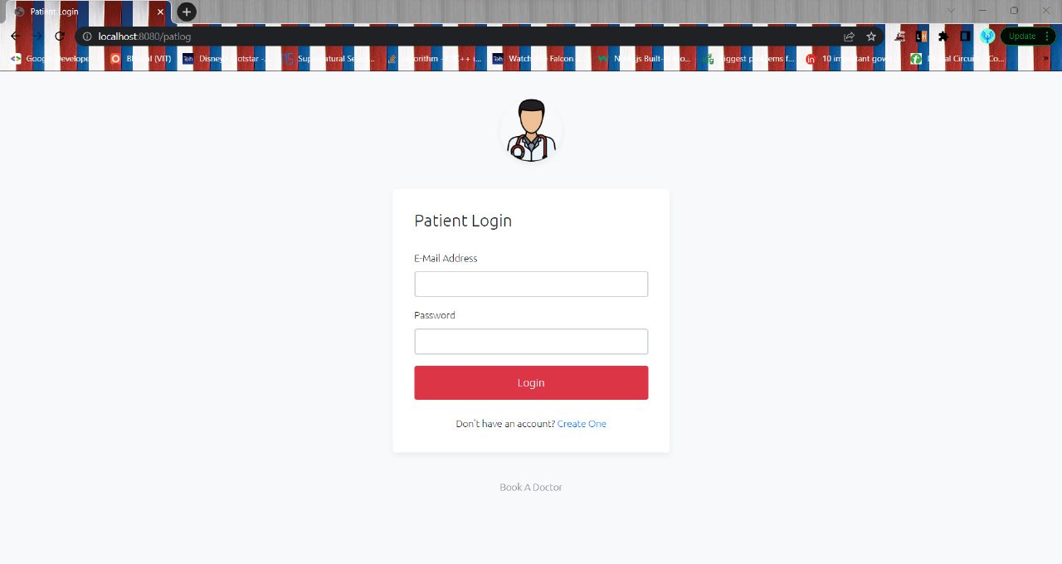

* Doctor Page Registration:



* Doctor Page Login:



* Doctor database:

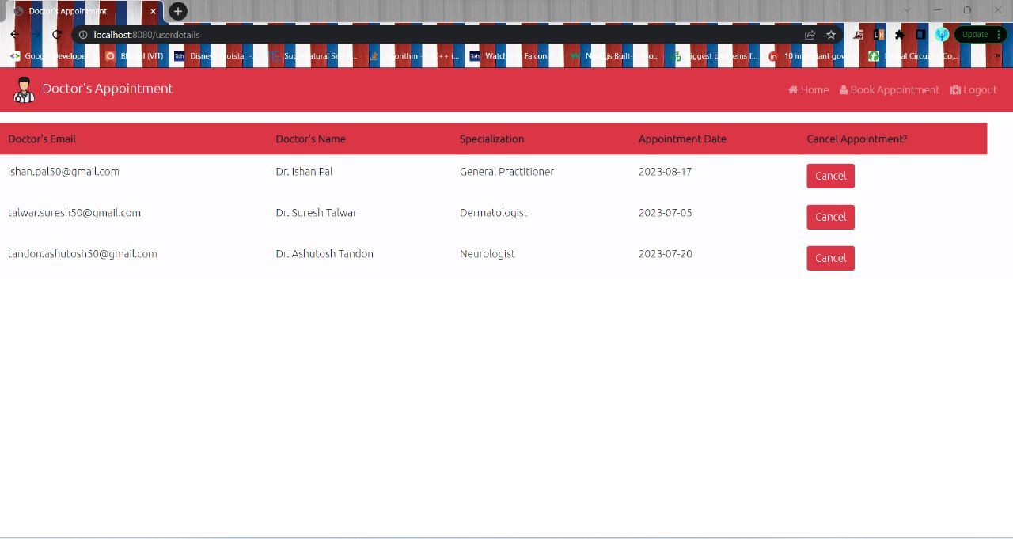



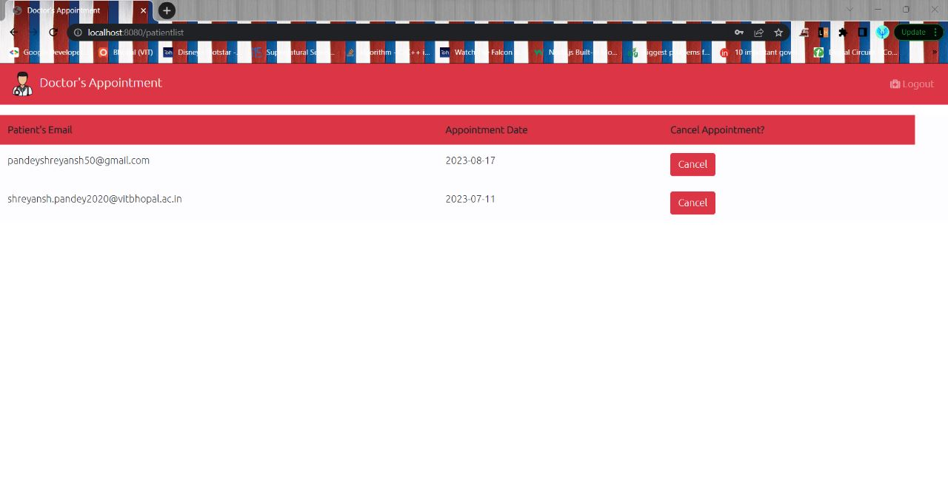

* **CODE -**



